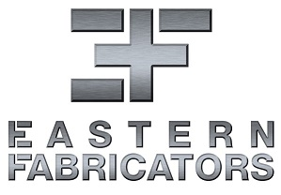
Mechanical Designer

November 19,2020

Eastern Fabricators has an immediate opening for a Mechanical Designer in our growing company. This position is based in our PEI GT or Woodstock, Ontario Facility.
Requirements:
- Minimum 2 years experience with 3D CAD modelling (Autodesk Inventor preferred)
- Working knowledge of AutoCAD
- Experience in creating fabrication drawings
- Background in machine design with a mechanical aptitude
- Ability to read and interpret Engineering Drawings
- Project management would be an asset but not required, potential for advancement for the right applicant
- Able to work in a fast-paced environment where teamwork is essential
- Good communications skills
- Strong Organizational and Planning Skills
- Proficiency with Microsoft Office
Responsibilities
- Prepare engineering designs & drawings based on preliminary concepts, sketches, calculations & customer specifications
- Examine drawings for conformity and errors
- Create Equipment Parts list for designs
- Participate in design review meetings
- Ability to meet deadlines
- General shop & office support
- Occasional travel will be required
Salary
- Commensurate with qualifications and experience
To apply, please send your resume, cover letter and, if possible, sample design drawings to Jeff MacDonald, jmacdonald@easternfabricators.com. For more information on Eastern Fabricators visit our website at www.easternfabricators.com. Applications will be received until December 4, 2020.

